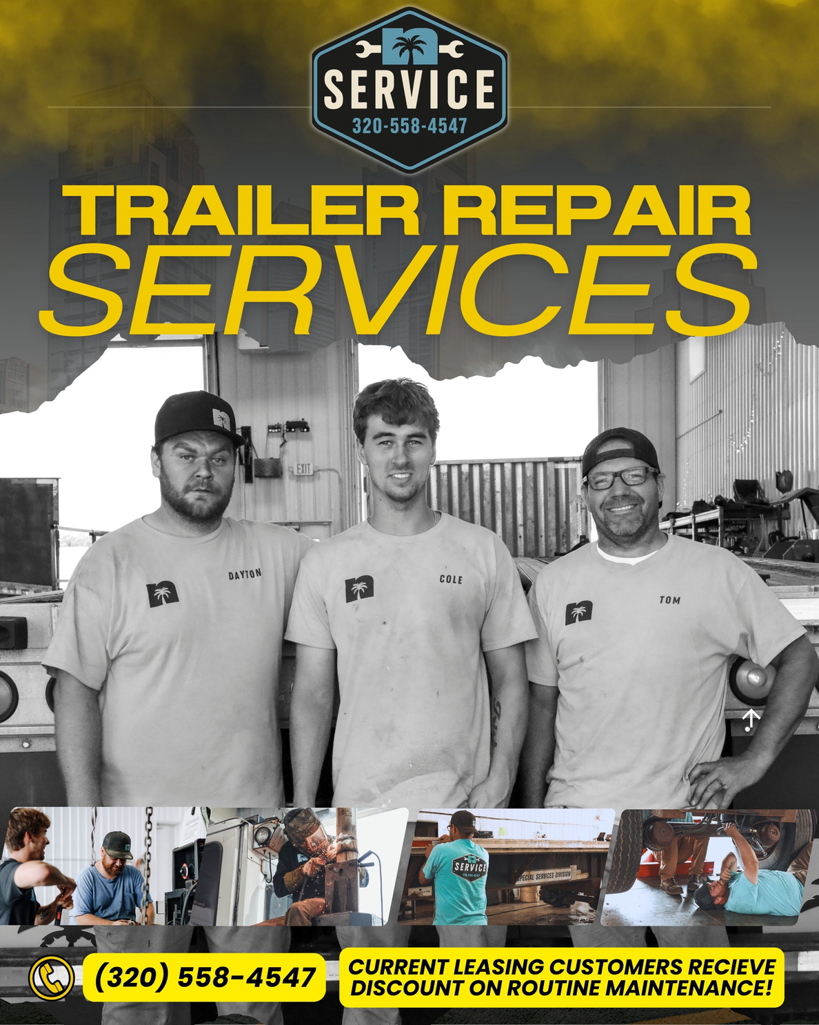
Equipment Repair & Mobile Service
Keep your equipment moving with fast, reliable service from Newport Leasing Group. Our experienced technicians provide professional trailer repair, maintenance, and on-site mobile service to minimize downtime and keep your operation running.
Free, No-Hassle Quotes • Fast Turnaround • Experienced Technicians
ASK US ABOUT TRUCK REPAIRS!
In-Shop Trailer Repair Services
Services offered but not limited to.
Our service center handles a wide range of equipment repairs and maintenance, including:
Brake & Wheel Systems
- Brake Repair & Replacement
- Wheel Seal Service
- Bumper Repair
Air & ABS Systems
- Air System Diagnostics & Repair
- Gladhands
- ABS System Service
Electrical & Lighting
- Electrical Diagnostics & Repair
- Light Repair & Replacement
- GPS Installation & Troubleshooting

Structural & General Repairs
- Door Repair & Replacement
- Light Patch Work & Minor Body Repair
Cleaning Services
- Trailer Wash Available
Mobile Trailer Repair – We Come to You
Reduce downtime with Newport’s Mobile Service. Our technicians provide on-site repairs at your yard, job site, or parking location.
Mobile services include:
- Light Repairs
- Air System Issues
- Electrical & Lighting Repairs
- Minor Brake Adjustments
- Tire Fills & Basic Service Support
Fast response. Professional service. Less disruption to your operation.
Cole’s Corner – Tools, Accessories & Driver Essentials
Located on-site, Cole’s Corner provides convenient access to the items drivers and fleets need every day:
- Tools & Shop Supplies
- Safety Equipment
- Truck & Trailer Accessories
- Driver Essentials
Everything you need to stay prepared and on the road.

Why Choose Newport Service?
- Free, No-Hassle Quotes
- Fast Turnaround Times
- Highly Experienced, Knowledgeable Technicians
- Mobile Service Available
- One-Stop Support: Service • Mobile Repair • Supplies • Parking • Rentals
Get a Free Quote Today
Call (320) 558-4547

